AI-Based Hotel Reviews Sentiment Analysis
Project Report

1. Introduction
With the rapid growth of online booking platforms, hotel customers actively share feedback through reviews and ratings. These reviews contain valuable insights about customer satisfaction, service quality, and operational gaps. However, manual analysis of thousands of reviews is impractical.
This project focuses on building an AI-based Sentiment Analysis system that automatically analyzes hotel reviews and classifies customer sentiment (Positive, Negative, Neutral), enabling hotels and decision-makers to take data-driven actions.

2. Business Objective
The primary objectives of this project are:
- To automatically analyze customer reviews using AI
- To identify positive and negative sentiment trends
- To help hotel management:
  - Improve service quality
  - Detect recurring complaints
  - Enhance guest experience
  - Benchmark hotel performance

Main Objective:
The primary objective of this datasheet is to analyze hotel performance and customer satisfaction using large-scale customer review data.
It is designed to help understand how guests perceive hotels based on ratings, written feedback, reviewer profiles, and temporal trends.
This datasheet serves as a structured dataset for analytics, reporting, and AI/ML modeling, with the following goals:
- Customer Sentiment Analysis
  - Analyze positive and negative reviews to understand guest satisfaction drivers.
  - Measure sentiment using word counts and review text.
- Hotel Performance Evaluation
  - Compare average hotel scores vs individual reviewer scores.
  - Identify high-performing and under-performing hotels.
- Behavioral & Demographic Insights
  - Study reviewer behavior using:
    - Reviewer nationality
    - Number of reviews given by a reviewer
    - Travel tags (family, business, couple, solo, etc.)
- Trend & Time-Based Analysis
  - Track how hotel ratings and reviews change over time using:
    - Review date
    - Days since review
- Geographical Analysis
  - Enable location-based insights using:
    - Hotel address
    - Latitude and longitude
- AI / ML Use Cases
  - Train models for:
    - Review sentiment classification
    - Rating prediction
    - Hotel recommendation systems
    - Customer experience improvement analysis

Implementation Plan - Sentiment Analysis on Hotel Reviews
I will create a Python script to perform sentiment analysis on the
Hotel_Reviews.csv dataset.
Goal Description
The goal is to analyze the sentiment of hotel reviews to understand the general feeling of the reviewers. We will use the Negative_Review and Positive_Review columns to form a complete review text and then compute sentiment scores.
Proposed Changes
Dependencies
- pandas for data manipulation
- nltk for sentiment analysis (VADER)
- matplotlib / seaborn for visualization
- wordcloud for text visualization
Steps
- Load Data: Read
…\PK\dataset_hotel_review\Hotel_Reviews.csv into a pandas DataFrame.
- Preprocessing:
  - Combine Negative_Review and Positive_Review into a single Review_Text column.
  - specialized cleaning (removing "No Negative" / "No Positive" placeholders).
- Sentiment Analysis:
  - Initialize NLTK's VADER SentimentIntensityAnalyzer.
  - Apply it to the Review_Text to get polarity scores (Positive, Negative, Neutral, Compound).
- Analysis & Visualization:
  - specific visualizations (Histogram of sentiment scores).
  - Correlation between Compound sentiment score and Reviewer_Score.
  - Generate WordClouds for positive and negative sentiment subsets.
- Output:
  - Save the results containing sentiment scores to a new CSV or print summary statistics.
Files to Create
[NEW]
sentiment_analysis.py
- Main script containing the logic.
Verification Plan
Automated Tests
- Run python sentiment_analysis.py and ensure it runs without errors and produces valid output (plots and specific print statements).
Manual Verification
- Inspect the output plots.
- Check a few sample reviews and their calculated sentiment scores to see if they make sense.

3. Dataset Overview (Hotel_Reviews.csv)
The dataset contains structured and unstructured data related to hotel reviews.
Key Attributes Used:
- Hotel_Name
- Hotel_Address
- Reviewer_Nationality
- Positive_Review
- Negative_Review
- Reviewer_Score
- Average_Score
- Review_Date
- Tags (travel type, stay purpose, etc.)
Nature of Data:
- Text data (reviews)
- Numerical data (scores)
- Categorical data (nationality, tags)
- Temporal data (review date)

4. Problem Statement
Hotels receive a massive volume of customer reviews daily. The challenge is to:
- Understand customer sentiment accurately
- Identify service strengths and weaknesses
- Extract actionable insights from unstructured text
Manual analysis is time-consuming and subjective. Hence, an AI-driven automated sentiment analysis system is required.

5. Proposed AI Solution
We propose an NLP (Natural Language Processing) based Sentiment Analysis system that processes hotel reviews and classifies them into sentiment categories.
Sentiment Classes:
- Positive
- Negative
- Neutral

6. System Architecture
High-Level Workflow:
- Data Ingestion
- Data Cleaning & Preprocessing
- Feature Engineering
- Sentiment Labeling
- Model Training
- Model Evaluation
- Insights & Dashboard Generation

7. Data Preprocessing
7.1 Data Cleaning
- Remove null or empty reviews
- Combine Positive_Review and Negative_Review fields
- Remove special characters, punctuation, numbers
- Convert text to lowercase
7.2 Text Normalization
- Tokenization
- Stopword removal
- Lemmatization / stemming

8. Sentiment Label Creation
Two approaches can be used:
Approach 1: Rule-Based (Initial Labeling)
- Reviewer_Score ≥ 7 → Positive
- Reviewer_Score ≤ 4 → Negative
- Score between 5–6 → Neutral
Approach 2: AI-Driven
- Use labeled data to train ML/DL models
- Predict sentiment directly from review text

9. Feature Engineering
Text Features:
- TF-IDF vectors
- N-grams (unigrams, bigrams)
- Word embeddings (Word2Vec, GloVe)
Metadata Features (Optional):
- Reviewer nationality
- Travel tags
- Length of review
- Review recency

10. Model Development
10.1 Machine Learning Models
- Logistic Regression
- Naive Bayes
- Support Vector Machine (SVM)
- Random Forest
10.2 Deep Learning Models (Advanced)
- LSTM / Bi-LSTM
- GRU
- Transformer-based models (BERT)

11. Model Training & Validation
- Split data into Train (70%), Validation (15%), Test (15%)
- Perform hyperparameter tuning
- Handle class imbalance if required

12. Evaluation Metrics
The system performance is evaluated using:
- Accuracy
- Precision
- Recall
- F1-Score
- Confusion Matrix

13. Output & Insights
Generated Outputs:
- Sentiment label per review
- Sentiment score per hotel
- Top positive & negative keywords
- Trend analysis over time
Business Insights:
- Identify hotels with declining sentiment
- Detect common complaints (cleanliness, staff, food)
- Improve targeted services

(venv) PS D:\proj\PK> python sentiment_analysis.py
Downloading NLTK VADER lexicon...
Loading data from dataset_hotel_review\Hotel_Reviews.csv...
Data loaded successfully. Shape: (515738, 17)
Preprocessing reviews...
Initializing VADER Sentiment Analyzer...
Calculating sentiment scores... This may take a while for large datasets.

--- Sentiment Analysis Summary ---
sentiment_type
Positive 0.752741
Negative 0.134902
Neutral 0.112357
Name: proportion, dtype: float64
Generating visualizations...
Saved sentiment_distribution.png to output
D:\proj\PK\sentiment_analysis.py:79: FutureWarning:

Passing `palette` without assigning `hue` is deprecated and will be removed in v0.14.0. Assign the `x` variable to `hue` and set `legend=False` for the same effect.

sns.countplot(x='sentiment_type', data=df, palette='viridis', order=['Positive', 'Neutral', 'Negative'])
Saved sentiment_count.png to output
D:\proj\PK\sentiment_analysis.py:87: FutureWarning:

Passing `palette` without assigning `hue` is deprecated and will be removed in v0.14.0. Assign the `x` variable to `hue` and set `legend=False` for the same effect.

sns.boxplot(x='sentiment_type', y='Reviewer_Score', data=df, palette='Set2', order=['Positive', 'Neutral', 'Negative'])
Saved score_vs_sentiment.png to output
Generating word clouds...
Saved word clouds to output

Analysis Complete.
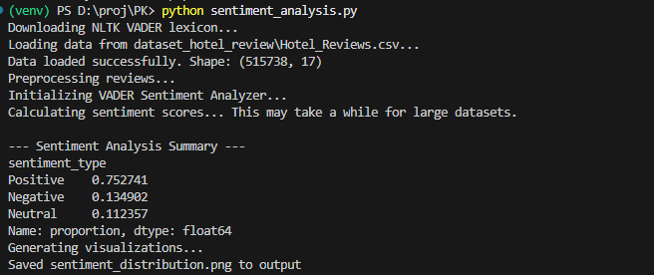
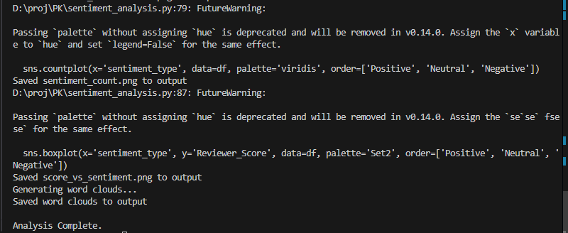
14. Dashboard & Reporting
An AI dashboard can be developed to show:
- Sentiment distribution (Pie / Bar charts)
- Hotel-wise sentiment score
- Time-based sentiment trends
- Word clouds for positive & negative reviews

15. Use Cases
- Hotel service quality improvement
- Customer experience management
- Competitive benchmarking
- Marketing strategy optimization
- Reputation management

16. Benefits of the AI System
- Automated and scalable analysis
- Faster decision-making
- Improved guest satisfaction
- Reduced operational risk
- Data-driven hotel management

17. Limitations & Challenges
- Sarcasm detection complexity
- Multilingual reviews
- Bias in review data
- Neutral sentiment ambiguity

18. Future Enhancements
- Multilingual sentiment analysis
- Aspect-based sentiment analysis (room, staff, food)
- Real-time review monitoring
- Integration with booking platforms
- Predictive customer satisfaction scoring

19. Conclusion
This AI-based Hotel Reviews Sentiment Analysis system transforms unstructured customer feedback into actionable intelligence. By leveraging NLP and machine learning techniques, hotels can proactively enhance service quality, improve guest experience, and gain a competitive advantage.

